Leading Digitals

Valtireo Business Plan
Comprehensive commercial, product, and execution plan
The Organizational OS for modern institutions and growing teams

Version | Comprehensive v2
Date | 2026-08-11
Prepared for | Valtireo product, design, content, project, and leadership team
Prepared by | Leading Digitals
Status | Working business plan for MVP execution, pilot sales, and partner conversations

Strategic thesis
Valtireo should enter the market through HR and people operations, then expand into a configurable organizational operating layer for documents, approvals, compliance, internal services, reporting, auditability, and later AI-assisted administration.

Table of Contents
- 1. Executive Summary
- 2. Strategic Context and Product Identity
- 3. Problem, Customer Pain, and Urgency
- 4. Market Opportunity
- 5. Target Customers and Ideal Customer Profile
- 6. Product Strategy and Architecture
- 7. MVP Scope and Roadmap
- 8. Business Model and Pricing Strategy
- 9. Go-To-Market Strategy
- 10. Marketing and Brand Strategy
- 11. Sales and Customer Success Motion
- 12. Team, Governance, and Operating Model
- 13. Financial Planning Assumptions
- 14. Metrics, Milestones, and Risk Management
- 15. Immediate Execution Plan
- Appendix A: Sources and Evidence Base

1. Executive Summary
Valtireo is a configurable Organizational OS by Leading Digitals. It gives institutions and growing teams one governed workspace for people, structure, documents, approvals, compliance, leave, attendance, reports, notifications, and audit-ready operations.
The first commercial wedge is HR and people operations because that is where many organizations already feel visible pain: incomplete records, document expiry risk, manual approvals, leave disputes, attendance gaps, spreadsheet reporting, and weak accountability. The long-term opportunity is broader: Valtireo can become the administrative operating layer for organizations that need clarity, control, and evidence across internal work.
Core promise
Give every person, process, document, request, and decision a clear place, owner, status, and audit trail.

Business area | Plan
Category | Organizational OS, entering through HR and people operations.
Primary customers | Schools, healthcare providers, NGOs, professional service firms, manufacturing/multi-location companies, and institution-style organizations.
MVP proof | A working backend already covers organizations, users, permissions, employees, documents, approvals, leave, attendance, reports, imports, notifications, audit logs, and activity feeds.
Commercial motion | Founder-led discovery, polished demo workspace, paid pilots, vertical packaging, then repeatable partner-assisted sales.
Strategic moat | Configurable organization-owned workflows, document compliance, multi-tenant foundation, auditability, and local institutional relevance.

2. Strategic Context and Product Identity
Valtireo should not be positioned as another HRMS clone. HR is the entry point; organizational governance is the larger product. The product should help organizations move from scattered administration to a structured operating model.
Identity element | Recommendation
Company | Leading Digitals
Product | Valtireo
Category | Organizational OS
Primary positioning | The Organizational OS for modern institutions and growing teams.
Product principle | Default enough to start. Configurable enough to own.
Brand personality | Structured, calm, trustworthy, practical, audit-ready, configurable, institution-ready.

Valtireo's public language should be concrete and operational: people, documents, approvals, compliance, reports, audit trails, and internal services. It should avoid vague startup language, AI hype, or overly playful HR messaging.

3. Problem, Customer Pain, and Urgency
Many organizations still run administration through spreadsheets, emails, paper files, messaging apps, and fragmented tools. This creates a silent operating cost: lost time, delayed decisions, poor reporting, weak accountability, and compliance exposure.
Pain area | What happens today | Valtireo response
Employee records | Employee data is scattered across files, forms, spreadsheets, and inboxes. | A complete employee record with profile, documents, history, reporting line, and activity trail.
Documents | Required documents are missing, expired, or reviewed informally. | Document requirements, expiries, reminders, compliance status, and review history.
Approvals | Decisions happen in chats and emails with unclear accountability. | Shared approval requests, configurable steps, approver strategy, notes, and decision logs.
Leave and attendance | Manual reconciliation creates disputes and poor visibility. | Leave balances, requests, attendance records, corrections, approvals, and reports.
Reporting | Leadership asks for updates that teams rebuild manually each month. | Named reports, filters, CSV exports, dashboards, and audit/activity visibility.

4. Market Opportunity
Global HCM and HR software markets continue to grow as organizations digitize workforce administration, compliance, payroll, analytics, and employee experience. The opportunity is especially relevant where institutions need more than basic HR records but cannot absorb heavyweight enterprise systems.
Signal | What it indicates | Source
Global HCM software growth | Research and Markets / The Business Research Company estimates the global HCM software market at $31.47B in 2026, reaching $44.74B by 2030 at a 9.2% CAGR. | Research and Markets, 2026
Broader HCM market expansion | Fortune Business Insights estimates HCM at $37.22B in 2026, growing to $76.22B by 2034 at a 9.40% CAGR. | Fortune Business Insights, 2026
Nigeria HR software demand | 6Wresearch estimates Nigeria Core HR Software at $811M in 2025 and $1.187B by 2032, with cloud adoption, automation, and analytics as key trends. | 6Wresearch, updated July 2026
Public-sector digitization | Nigeria's Federal Government launched HR modules for IPPIS on July 27, 2026, reinforcing institutional digitization momentum. | Federal Ministry of Information, 2026

Market interpretation
Valtireo should not chase the entire global HCM category at once. The sharper beachhead is institution-ready HR operations for organizations that need document compliance, approvals, auditability, local relevance, and configuration ownership.

5. Target Customers and Ideal Customer Profile
The best early customers have enough complexity to feel the pain, but not so much procurement complexity that sales cycles stall before learning happens.
Segment | Why it fits | Initial offer
Schools and universities | Staff records, document requirements, leave approvals, multi-campus structure, and compliance reporting. | Digitize staff records, documents, leave, and approval workflows.
Healthcare providers | License/document compliance, shift/attendance needs, strict roles, and departmental visibility. | Track employee documents, expiries, attendance, and approvals.
NGOs and foundations | Project/location complexity, donor reporting, compliance discipline, and lean admin teams. | Create a governed people operations and reporting workspace.
Professional firms | Growing teams, recurring HR processes, approvals, and leadership reporting needs. | Replace spreadsheets with employee records, leave, and reports.
Manufacturing/multi-location companies | Locations, shifts, attendance records, employee documents, and supervisors. | Start with HR core, attendance, and compliance reports.

The initial buyer is usually a CEO, managing director, COO, HR director, head of administration, or institutional leader responsible for order and accountability. The users are HR officers, compliance officers, department heads, supervisors, employees, and ICT/admin support.

6. Product Strategy and Architecture
Valtireo should be built and explained as a layered platform: product experience, modules, configuration, governance, and technical foundation. This keeps the MVP focused while preserving the long-term expansion story.
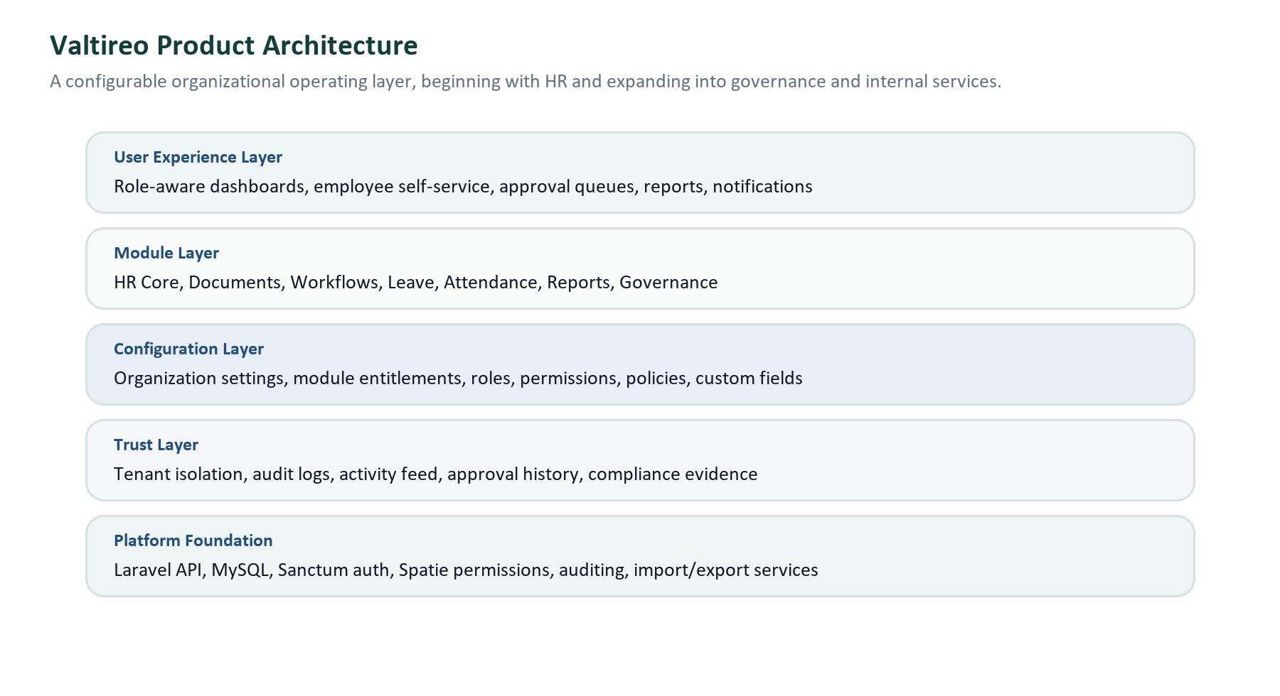
Figure 1: Valtireo operating-layer architecture.
Module | MVP role | Commercial value
Valtireo Core | Organization setup, users, roles, permissions, workspace settings, module entitlements. | Creates the platform foundation for multi-tenant SaaS and customer-specific workspaces.
Valtireo HR | Employee directory, onboarding, profile, custom fields, emergency contacts, dependents, reporting history. | Solves the first painful workflow: trusted employee records.
Valtireo Documents | Document types, requirements, expiry tracking, reviews, compliance summaries. | Differentiates from basic HR systems and speaks directly to compliance risk.
Valtireo Workflows | Shared approval engine for documents, leave, and attendance corrections. | Creates a reusable control layer across modules.
Valtireo Leave | Leave types, entitlements, requests, balances, approvals, cancellation. | Adds daily HR utility and management visibility.
Valtireo Attendance | Attendance settings, shifts, records, corrections, approval flow. | Supports operational organizations with time/exception visibility.
Valtireo Reports and Governance | Reports, CSV exports, notifications, audit logs, activity feeds. | Helps leadership trust data and reduce manual reporting.

7. MVP Scope and Roadmap
The first release should be a demo-ready HR MVP that proves Valtireo can operate as a serious institution-ready people operations platform. It should not attempt to complete every future product line.
In scope for MVP | Post-MVP / later
Auth, organization setup, workspace settings, roles, permissions, module entitlements | Complex SSO, LDAP, SAML, full enterprise identity suite
Employees, onboarding, profile extensions, custom fields, activity timeline | Recruitment, performance, learning, complex qualifications
Documents, requirements, expiry, compliance summary, reviews | Advanced document automation and external e-signature workflows
Shared approvals, leave, attendance, reports, imports, notifications, audit logs | Payroll, claims, finance/admin workflows, advanced BI, mobile app
Frontend app shell, core screens, demo workspace, pilot readiness | Operational OS modules such as inventory, procurement, fleet, warehouse, logistics, and field operations

Roadmap View
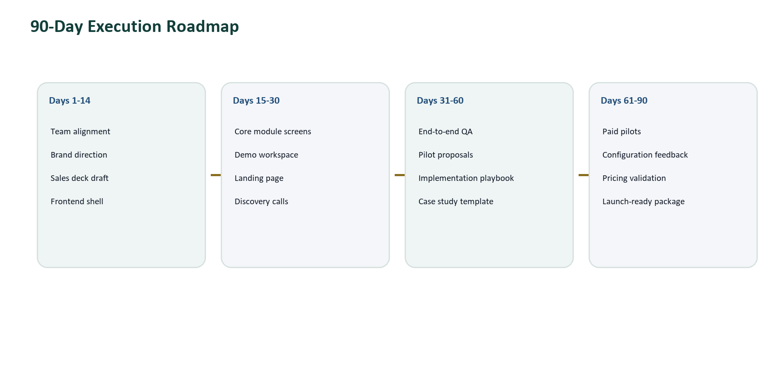
Figure 2: 90-day execution roadmap from alignment to paid pilots.

8. Business Model and Pricing Strategy
Valtireo should use a hybrid SaaS and implementation model. The subscription creates recurring revenue, while onboarding/configuration fees reflect the real work of moving organizations from scattered records into a governed operating workspace.
Revenue stream | Description | Why it matters
SaaS subscription | Monthly or annual subscription by employee band, module bundle, and support level. | Creates predictable recurring revenue.
Implementation/onboarding fee | One-time setup for organization structure, roles, modules, imports, and admin training. | Funds customer activation and filters serious buyers.
Configuration services | Paid support for policies, fields, approval workflows, reports, and vertical presets. | Monetizes Valtireo's configuration ownership without custom code sprawl.
Training and support retainers | Optional recurring support for larger institutions. | Improves retention and customer success.
Future module expansion | Payroll, recruitment, performance, service desk, AI, and Operational OS modules. | Creates account expansion and upsell paths.

Tier | Ideal customer | Likely package
Starter | Small organizations validating structured HR operations. | HR core, documents basics, leave basics, attendance basics, standard reports.
Growth | Growing teams with HR/admin complexity. | Full MVP modules, approvals, imports/exports, reports, audit/activity, priority support.
Institution | Schools, healthcare groups, NGOs, agencies, larger multi-location organizations. | Multi-location setup, branded workspace, advanced configuration, dedicated onboarding, SLA support.
Enterprise | Large institutions with procurement, integration, or hosting requirements. | Custom contract, implementation plan, integrations, advanced support, later SSO/data-residency options.

Pricing discipline
Do not lock final prices before discovery. Validate willingness to pay through pilots across schools, healthcare, NGOs, and private enterprises. Start with simple bands, then refine after real buying conversations.

9. Go-To-Market Strategy
The first go-to-market motion should be founder-led and pain-specific. Valtireo should avoid broad 'all-in-one HR' messaging and instead sell a concrete transformation: from scattered records and informal approvals to a structured, auditable workspace.
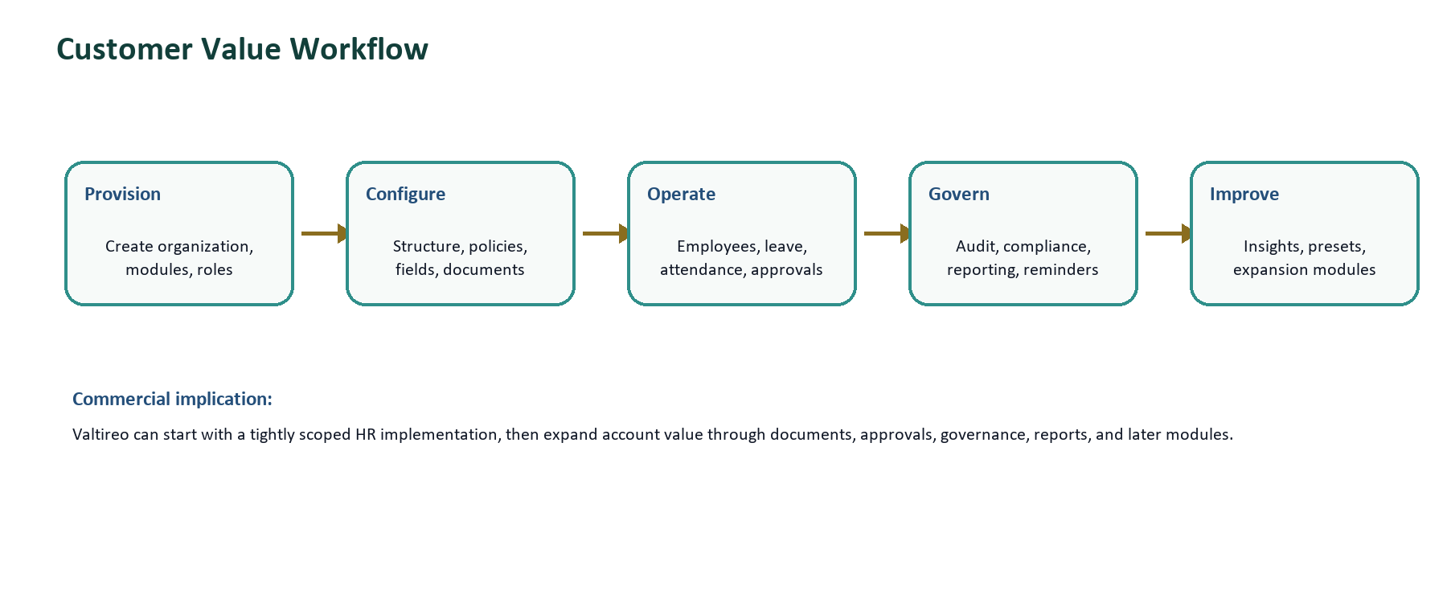
Figure 3: Customer value workflow and account expansion logic.
Phase | Objective | Execution focus
Phase 1: Validation | Confirm the sharpest buyer pain and best first segment. | 20-30 discovery/demo calls, objection tracking, demo script refinement, pilot candidate identification.
Phase 2: Paid pilots | Convert interest into implementation learning and revenue. | 60-90 day paid pilots, real workspace configuration, measurable before/after outcomes.
Phase 3: Repeatability | Turn founder-led learning into a repeatable sales motion. | Vertical packages, case studies, partner channels, sales deck, email sequence, referral network.
Phase 4: Expansion | Grow customer account value. | Add documents, approvals, reports, compliance workflows, future modules, and support retainers.

10. Marketing and Brand Strategy
Valtireo's marketing should sound precise, institution-ready, and operational. It should speak to people responsible for order: founders, HR leaders, administrators, compliance officers, and department heads.
Content pillar | Purpose | Example angle
Organizational clarity | Explain the larger OS idea beyond HR. | Structure your organization before complexity takes over.
Document compliance | Own a sharp differentiator. | Stop chasing employee documents.
Approval governance | Show accountability and process maturity. | Give every approval a trail.
HR digitization | Meet the buyer's immediate category expectation. | Your HR spreadsheet is doing too much.
Audit-ready administration | Speak to leadership, compliance, and public-sector trust. | Know who changed what, when, and why.
Institutional digital transformation | Position Valtireo for schools, healthcare, NGOs, and public institutions. | A practical operating layer for modern institutions.

Priority marketing assets should include a landing page, one-page product brief, sales deck, demo video, LinkedIn launch sequence, email outreach sequence, compliance checklist lead magnet, and pilot case-study template.

11. Sales and Customer Success Motion
Early sales should be consultative. The buyer must feel that Valtireo understands their current administrative reality before seeing the product as a credible solution.

Sales Process
- Identify target organization and buyer.
- Interview HR/admin leader to map current workflow.
- Show a demo around one painful workflow, not every feature.
- Offer a paid pilot with defined modules and success metrics.
- Configure organization structure, users, roles, documents, leave, attendance, and reports.
- Measure time saved, compliance gaps resolved, and reports produced.
- Convert to annual subscription and expand modules over time.
Discovery question | What it reveals
Where are employee records stored today? | Data fragmentation and migration complexity.
How do you know documents are missing or expired? | Compliance pain and urgency.
How are leave requests approved? | Workflow maturity and decision trail gaps.
How do you track attendance and corrections? | Operational visibility and exception management needs.
What reports does leadership ask for monthly? | Reporting value and executive buyer relevance.
What happens when someone asks for an audit trail? | Governance maturity and risk exposure.

12. Team, Governance, and Operating Model
The proposed lean team is appropriate for this stage, but the roles must be precise. The founder should act as product and business owner, not only supervisor. The project manager should protect delivery rhythm, while design and content shape market credibility.
Role | Primary ownership | Key deliverables
Founder / product lead | Vision, scope, customer discovery, pricing, partnerships, final product decisions. | Business plan, product direction, discovery calls, pilot deals, prioritization decisions.
Creative designer | Brand identity, product UI direction, design system, sales collateral visual quality. | Brand direction board, design tokens, product shell mockups, module screens, deck template.
Content creator | Positioning, launch copy, product explainers, outreach, demo narrative. | Landing page copy, product brief, sales deck copy, content calendar, demo script, case-study template.
Project manager | Sprint rhythm, delivery tracking, QA coordination, decision log, risk register. | MVP delivery plan, sprint board, launch checklist, QA tracker, meeting notes.
Engineering / implementation | Frontend integration, backend stabilization, deployment, testing, technical documentation. | Working product, API integration, QA fixes, deployment, release notes.

Founder focus
Stay closest to customer pain, product strategy, demo story, revenue path, and quality bar. Delegate production work, but retain final judgment over what Valtireo is becoming.

13. Financial Planning Assumptions
At this stage, the financial plan should be assumption-led rather than pretending to have precise forecasts. The goal is to define what must be validated during pilots and early sales.
Assumption area | Planning assumption | Validation method
Average customer size | Initial ICP likely ranges from 50-1,000 employees, with the first practical pilots in smaller/mid-size institutions. | Track employee count and complexity during discovery calls.
Revenue model | Subscription plus onboarding/configuration fee is stronger than subscription-only for institution-style customers. | Test paid pilot proposals with explicit setup fee.
Sales cycle | Private institutions and SMEs should close faster than public-sector or large enterprise buyers. | Track days from first call to pilot agreement by segment.
Implementation effort | First customer setup will require guided configuration, data import support, and training. | Measure hours spent per pilot and standardize the playbook.
Expansion path | Documents, approvals, reports, and governance create upsell value beyond basic HR records. | Track module adoption and buyer requests during pilots.

Use of funds / resources | Near-term priority
Frontend implementation | Complete role-aware app shell, dashboards, employees, documents, approvals, leave, attendance, reports, notifications, and audit screens.
Design | Create brand direction, design tokens, core screens, sales deck, product brief, and polished launch visuals.
Content and marketing | Develop landing page, product copy, outreach content, demo script, sales deck narrative, and launch calendar.
QA and deployment | Stabilize demo environment, test workflows, validate imports/exports, and prepare pilot-ready deployment.
Sales and customer development | Run discovery calls, demos, pilot proposals, partner outreach, and case-study capture.

14. Metrics, Milestones, and Risk Management
Metric category | Metrics to track
Product usage | Organizations provisioned, active users, employees created, profiles completed, documents submitted, approvals processed, leave requests, attendance records, reports exported.
Commercial | Discovery calls, demo calls, pilot proposals, pilot conversion rate, MRR, annual contract value, onboarding fee revenue, time to close.
Customer success | Setup checklist completion, time to first employee import, time to first report export, admin hours saved, compliance gaps resolved.
Operational | Sprint completion rate, unresolved QA issues, module readiness, documentation completeness, customer-request backlog.

Risk | Severity | Mitigation
Scope creep into payroll, recruitment, performance, assets, or operations too early. | High | Protect MVP scope and move non-critical requests into post-MVP unless tied to a paid pilot.
Valtireo is perceived as generic HR software. | High | Lead with Organizational OS, documents, approvals, compliance, audit trail, and configuration ownership.
Frontend complexity slows delivery. | Medium | Build reusable tables, forms, filters, status badges, approval panels, and navigation guards.
Long sales cycles in public-sector or large institutions. | Medium | Start with private schools, clinics, NGOs, and growing companies while nurturing larger opportunities.
Each customer asks for custom policies. | Medium | Use controlled configuration and vertical presets instead of one-off custom development.

15. Immediate Execution Plan
Timeframe | Business priorities | Product/team priorities
Next 7 days | Finalize business plan, product brief, team task board, discovery list. | Confirm frontend plan, assign owners, align on MVP boundaries.
Next 14 days | Sales deck v1, landing copy, brand direction board, first outreach. | App shell, dashboard design, core screens, demo script.
Next 30 days | 20-30 discovery calls, pilot candidates, landing page, demo workspace. | Frontend integration for core modules, end-to-end QA, demo data.
Next 60-90 days | 2-3 paid pilots, pricing validation, case-study capture, partner pipeline. | Pilot configuration, onboarding playbook, module refinements, launch package.

Near-term success definition
Valtireo does not need to prove every future module in the next 90 days. It needs to prove that real organizations will pay to replace scattered HR records, manual approvals, document compliance tracking, and spreadsheet reporting with one governed workspace.

Appendix A: Sources and Evidence Base
- Research and Markets / The Business Research Company, Human Capital Management Software Market Report 2026: https://www.researchandmarkets.com/report/global-human-capital-management-software-market
- Fortune Business Insights, Human Capital Management Market Size, Share and Industry Analysis, 2026-2034: https://www.fortunebusinessinsights.com/industry-reports/human-capital-management-hcm-market-100240
- 6Wresearch, Nigeria Core HR Software Market 2026-2032 Outlook: https://www.6wresearch.com/industry-report/nigeria-core-hr-software-market
- Federal Ministry of Information and National Orientation, FG Launches IPPIS Human Resource Modules, July 27, 2026: https://fmino.gov.ng/fg-launches-ippis-human-resource-modules-deepens-digital-transformation-of-civil-service/
- Internal product sources: Valtireo Product and MVP Status, Customization Ownership Strategy, HR MVP Frontend Handoff Guide, Brand and Product Design Foundation, and OrangeHRM review notes in the repository docs folder.

Strategic Conclusion
Valtireo should win by becoming the trusted operating layer for organizations that need structure, visibility, compliance, and accountability. The MVP should prove a focused and commercially understandable idea: a modern organization should know who its people are, what documents are required, which approvals are pending, what decisions were made, and what risks need attention.
HR is the beginning. Organizational control is the larger product.

